SEMINAR REPORT

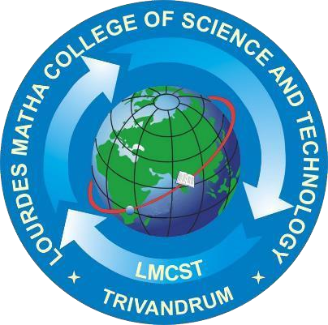

Submitted By: **ARUN SHANKAR S LMC23MCA-2015**

**AI DRIVEN IMAGE GENERATION USING STABLE DIFFUSION MODEL**

DEPARTMENT OF COMPUTER APPLICATIONS

[Affiliated to APJ Abdul Kalam Technological University, Kerala (KTU)]

**LOURDES MATHA COLLEGE OF SCIENCE AND TECHNOLOGY**

**KUTTICHAL, THIRUVANANTHAPURAM-695574 (MANAGED BY THE ARCHDIOCESE OF CHANGANASSERY)**

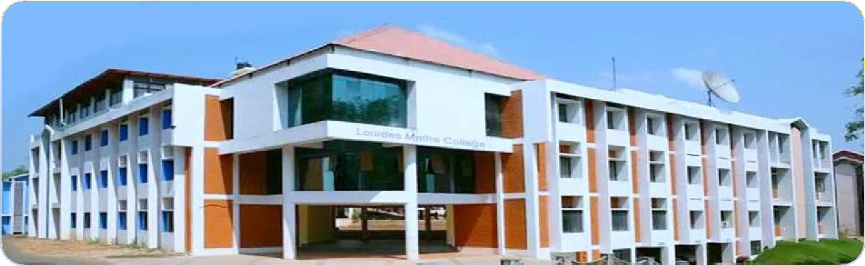

LOURDES MATHA COLLEGE OF SCIENCE AND TECHNOLOGY (MANAGED BY THE ARCHDIOCESE OF CHANGANASSERY)

KUTTICHAL, THIRUVANNTHAPURAM-695574

PHONE: 0472-2853550,2853682.2853546

WEBSITE: [www.lmcst.ac.in](http://www.lmcst.ac.in/)